|  |  |
| --- | --- |
| **TEAM ID** | **PNT2022TMID20743** |
| **PROJECT NAME** | **VirtualEye - LifeGuard for Swimming Pools to Detect Active Drowning** |

**CREATE DATABASE**

**Step 1: Before you begin:**

Create a service instance and credentials

**Python version requirement**

You must have a current version of the Python programming language that is installed on your system.

1. Check that Python is installed by running the following command at a prompt.

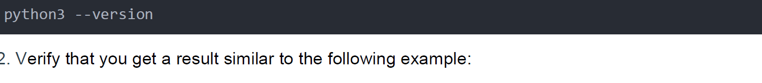

1. Verify that you get a result similar to the following example:

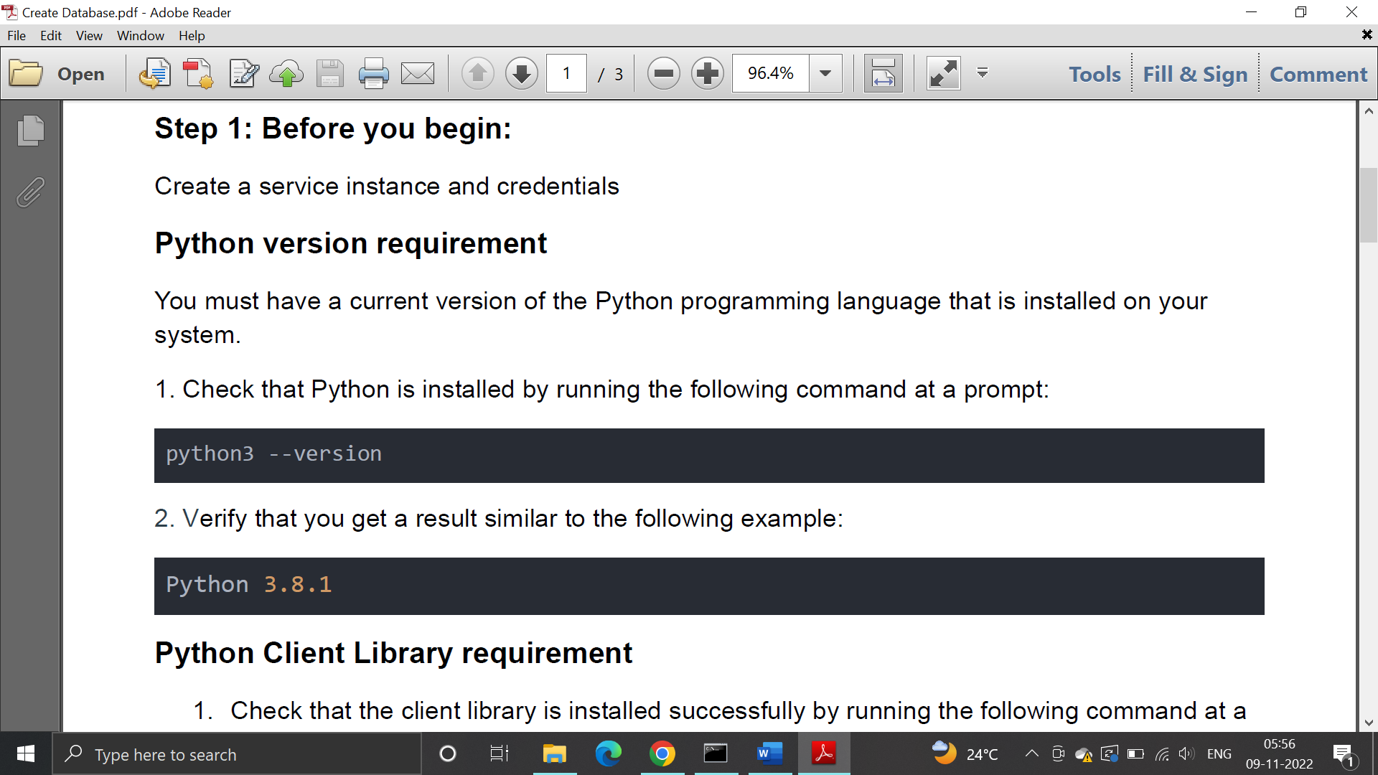

**Python Client Library requirement**

1. Check that the client library is installed successfully by running the following command at a prompt:

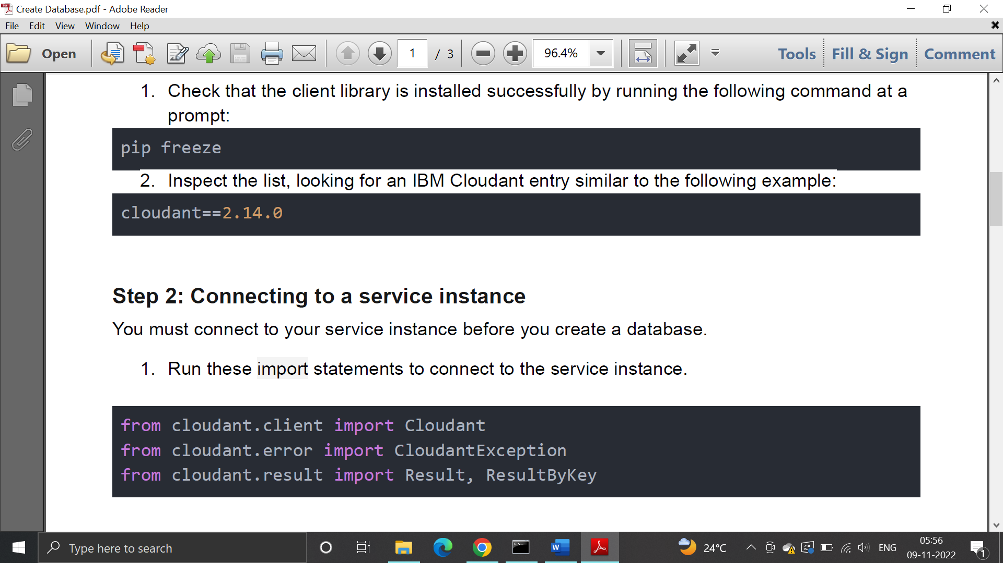

2.Inspect the list, looking for an IBM Cloudant entry similar to the following example:



**Step 2: Connecting to a service instance**

You must connect to your service instance before you create a database.

1. Run these import statements to connect to the service instance.



2. Find username, password, and URL in your Classic service credentials and replace serviceUsername, servicePassword, and serviceURL in the following example.

3. Establish a connection to the service instance.

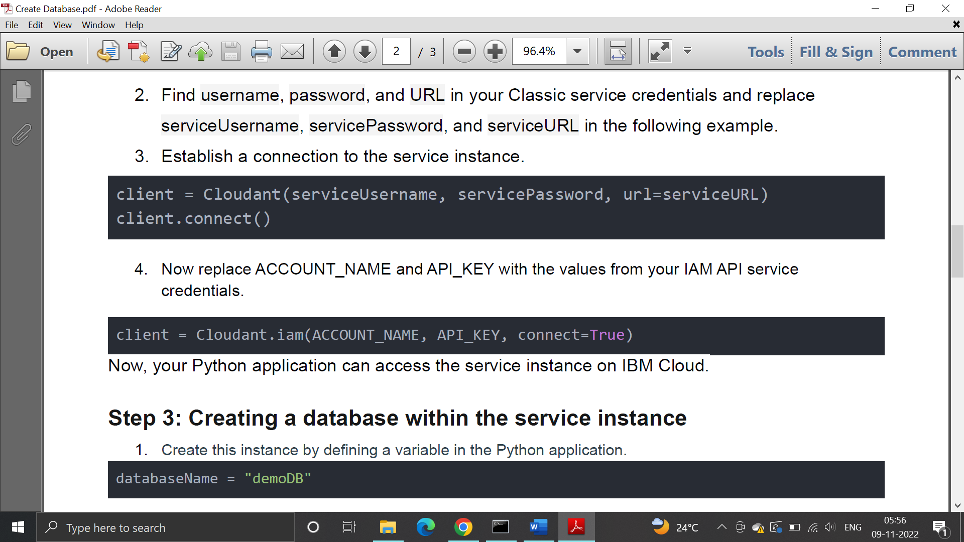

4. Now replace ACCOUNT_NAME and API_KEY with the values from your IAM API service

credentials.



Now, your Python application can access the service instance on IBM Cloud.

**Step 3: Creating a database within the service instance**

1. Create this instance by defining a variable in the Python application.



1. Create the database.

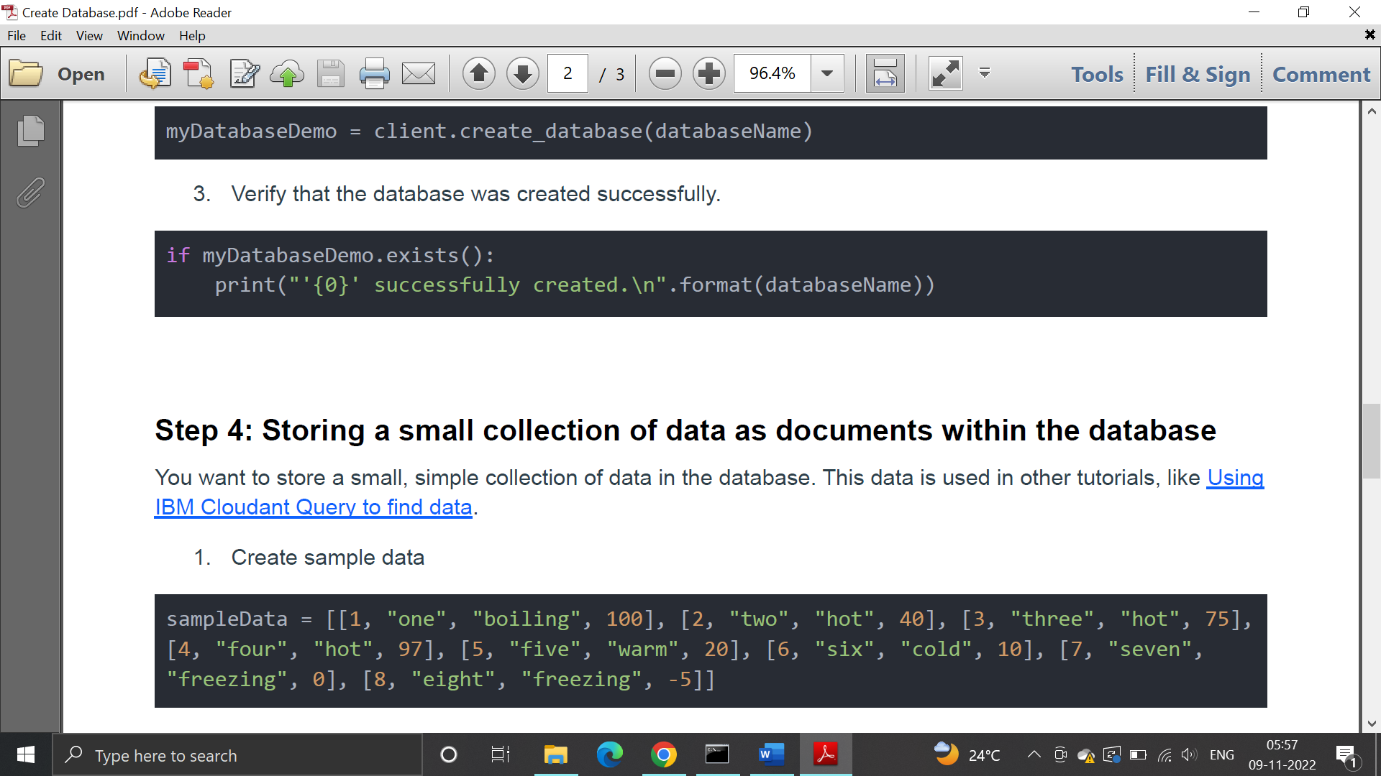

1. Verify that the database was created successfully.



**Step 4: Storing a small collection of data as documents within the database**

You want to store a small, simple collection of data in the database. This data is used in other tutorials, like Using

IBM Cloudant Query to find data.

1. Create sample data



2.Use a for statement to retrieve the fields in each row by going through each row in the array

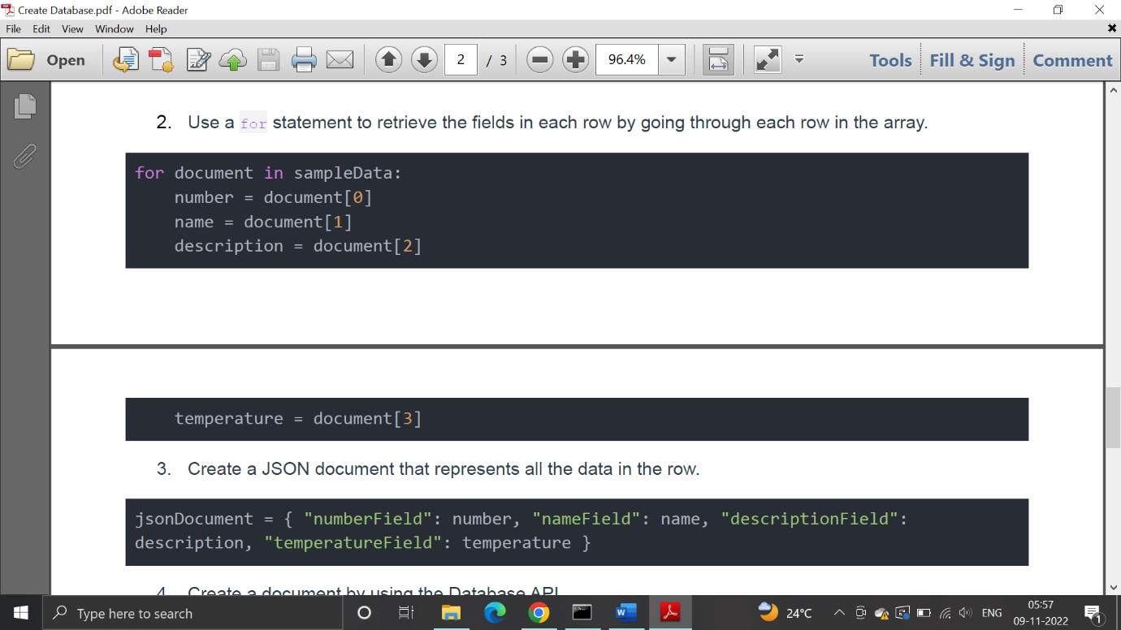



3.Create a JSON document that represents all the data in the row.



1. Create a document by using the Database API.

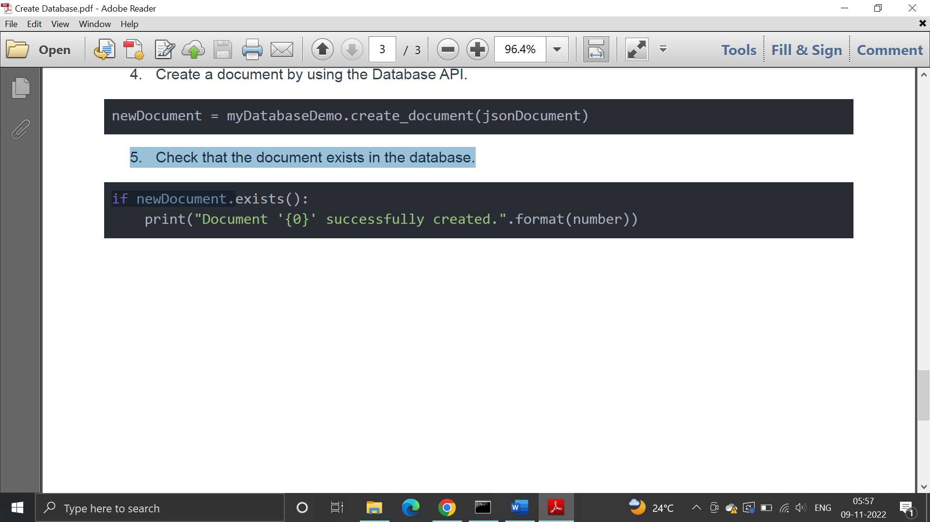

1. Check that the document exists in the database.

